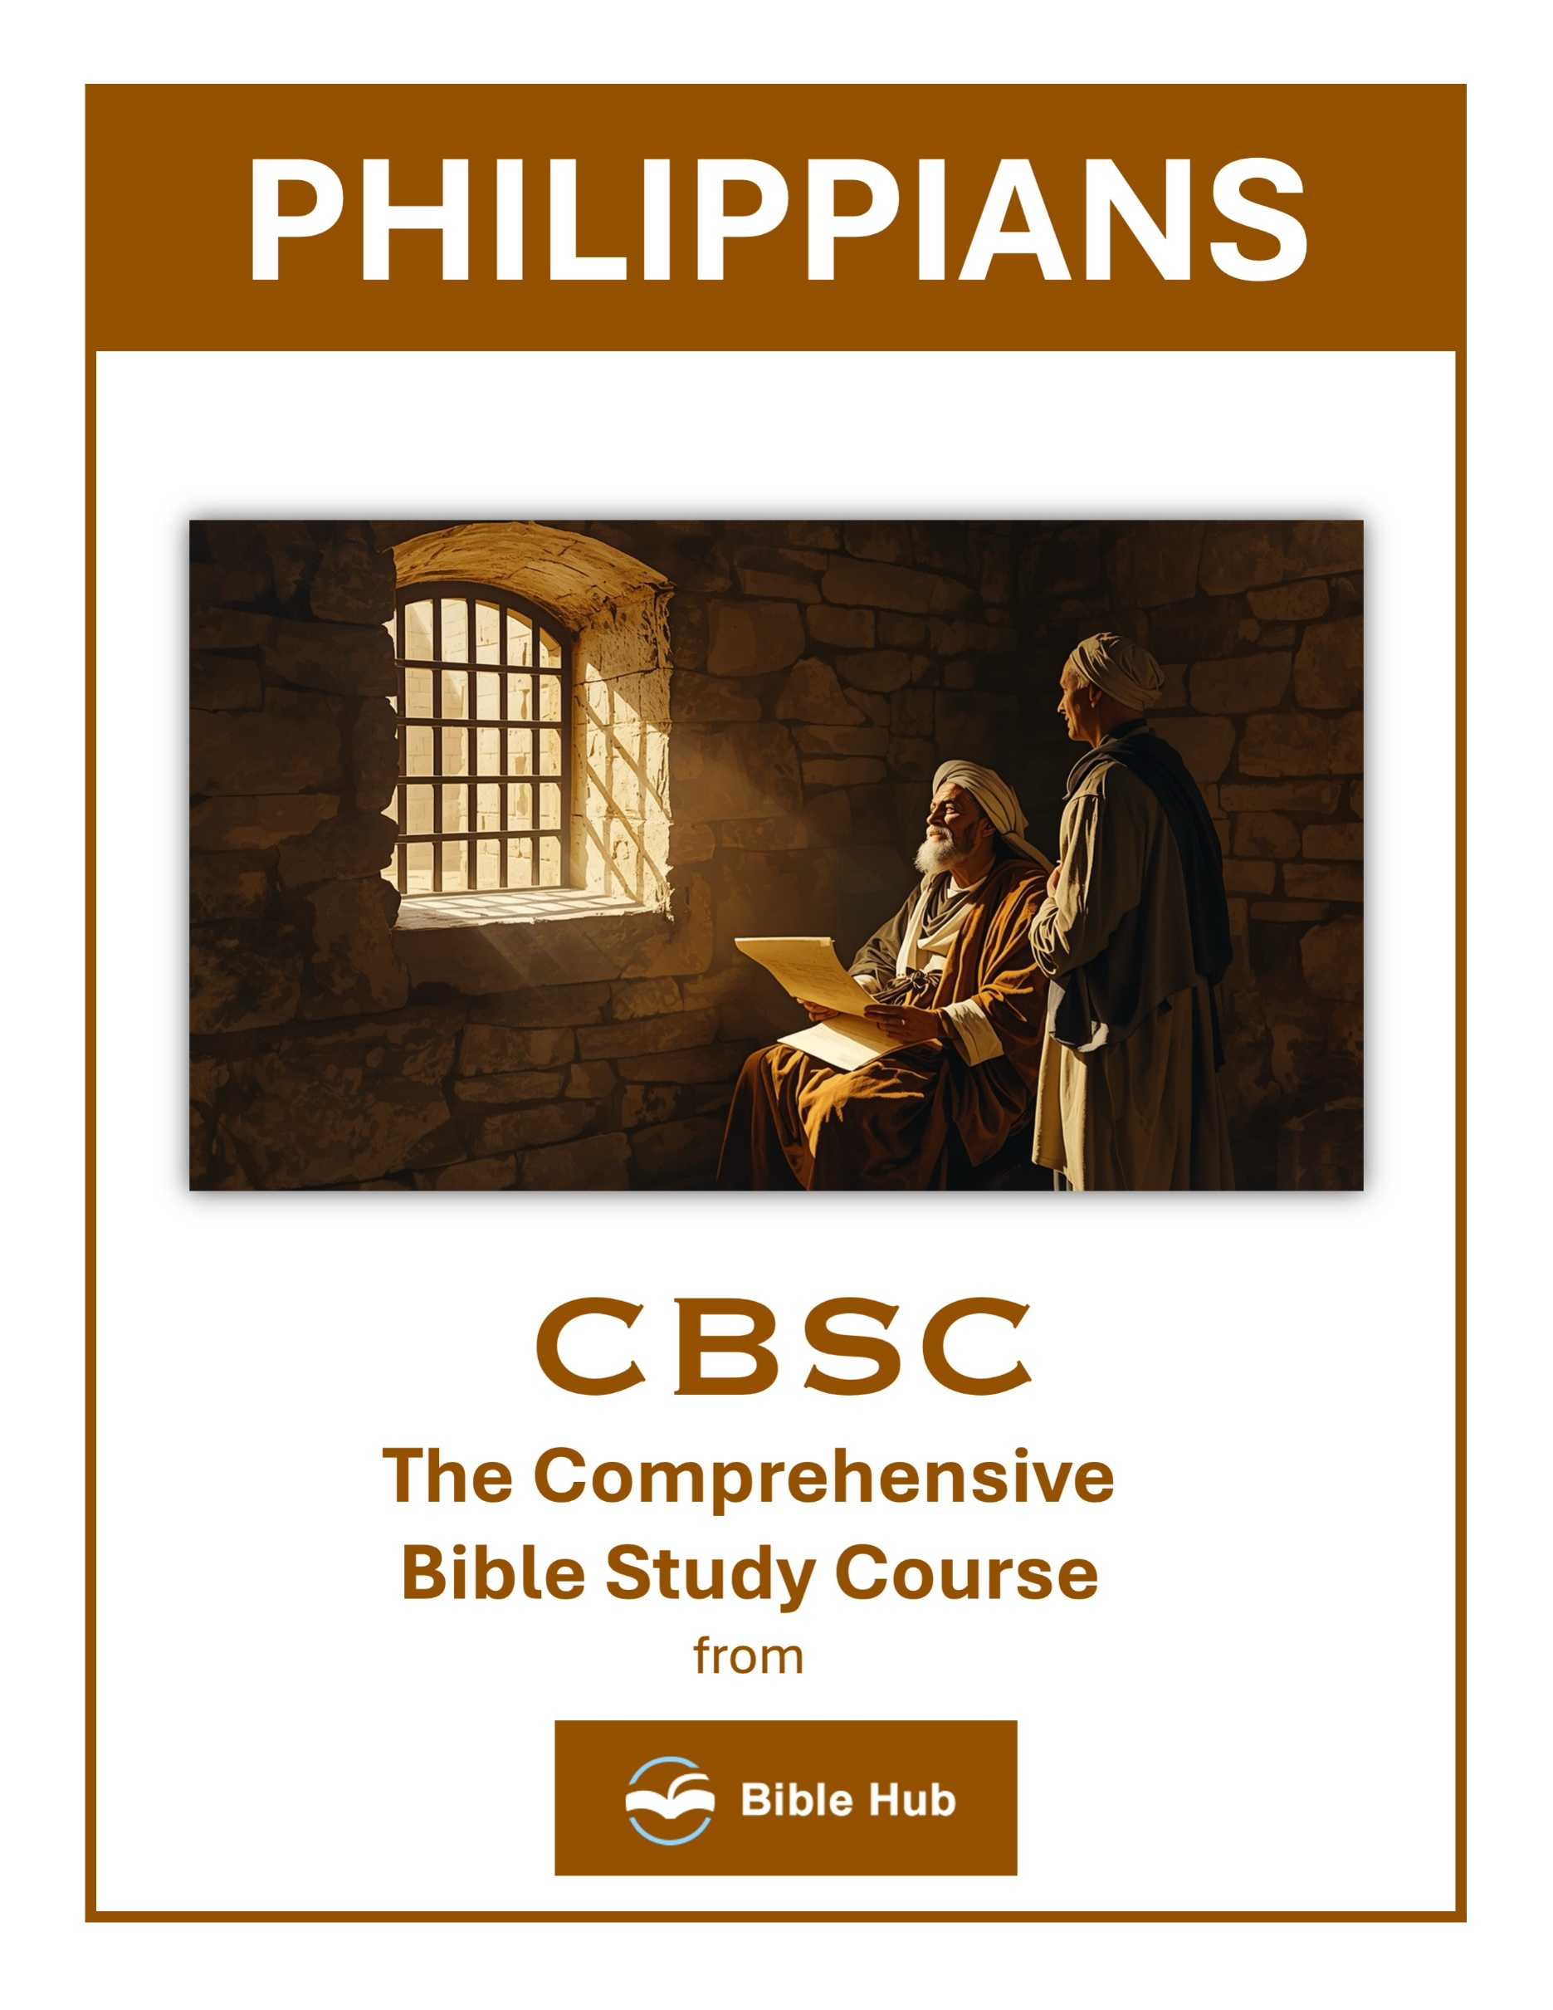

Philippians 1 Teaching Points and Bible Study Questions
Joy in All Circumstances
Philippians 1 teaches us that joy is not dependent on our circumstances but on our relationship with Christ. Paul writes from prison, yet he exudes joy, saying, "I always pray with joy in every prayer for all of you" (Philippians 1:4). This reminds us that true joy comes from knowing Christ and trusting in His plan, regardless of our situation.
1. How can you find joy in challenging situations like Paul did while in prison?
2. What practical steps can you take to maintain joy during difficult times?
3. Why does focusing on gratitude help cultivate joy in all circumstances?
Partnership in the Gospel
Paul emphasizes the importance of community and partnership in spreading the Gospel. He expresses gratitude for the Philippians' partnership, stating, "because of your partnership in the gospel from the first day until now" (Philippians 1:5). This highlights the power of working together in faith to further God's kingdom.
1. How can you actively support others in your community to advance the Gospel together?
2. What do you hope to achieve through your partnership in spreading the Gospel?
3. Why do you think partnership is essential for effective Gospel ministry in today's world?

Confidence in God's Work
We can be confident that God will complete the work He has started in us. Paul assures the Philippians, "being confident of this, that He who began a good work in you will continue to perfect it until the day of Christ Jesus" (Philippians 1:6). This encourages us to trust in God's ongoing work in our lives.
1. How can you develop confidence in God's work in your life despite current challenges?
2. What do you hope to see as evidence of God's work in your community?
3. Why does trusting in God's work impact your daily decisions and actions?
Abounding Love and Knowledge
Paul prays for the Philippians' love to abound more and more in knowledge and depth of insight. He writes, "And this is my prayer: that your love may abound more and more in knowledge and depth of insight" (Philippians 1:9). This teaches us that love, guided by wisdom and understanding, is essential for living a life that honors God.
1. How can you practically increase your love and knowledge in your daily interactions with others?
2. Why do you think abounding love is essential for making wise and discerning decisions?
3. What steps can you take to ensure your love is guided by knowledge and insight?

Living for Christ
Paul's declaration, "For to me, to live is Christ and to die is gain" (Philippians 1:21), challenges us to evaluate our priorities. Living for Christ means making Him the center of our lives, finding purpose and fulfillment in serving Him above all else.
1. How can you prioritize living for Christ in your daily decisions and interactions with others?
2. What do you hope to achieve by living a life centered on Christ's teachings?
3. Why does living for Christ sometimes require personal sacrifice, and how can you embrace it?
The Power of Prayer
Paul's reliance on prayer is evident as he expresses confidence that through the prayers of the Philippians and the help of the Spirit, he will be delivered. "For I know that through your prayers and the provision of the Spirit of Jesus Christ, my distress will turn out for my deliverance" (Philippians 1:19). This underscores the transformative power of prayer in our lives.
1. How can you incorporate Paul's example of prayer in Philippians 1 into your daily routine?
2. Why do you think Paul emphasizes joy and gratitude in his prayers for others?
3. What can you learn from Paul's prayers about trusting God's work in others' lives?

Courage in Adversity
Paul encourages the Philippians to stand firm in their faith, even in the face of opposition. He writes, "without being frightened in any way by those who oppose you" (Philippians 1:28). This reminds us to be courageous and steadfast, trusting in God's strength during challenging times.
1. How can you find courage in adversity by following Paul's example in Philippians 1?
2. What do you hope to achieve by facing challenges with courage as Paul did?
3. Why does Paul's perspective on adversity inspire you to act courageously in your own life?
Unity in Spirit
Unity among believers is a recurring theme in Philippians. Paul urges the church to "stand firm in one spirit, contending as one man for the faith of the gospel" (Philippians 1:27). This calls us to work together in harmony, united by our shared faith and purpose.
1. How can you actively promote unity in spirit within your community or church group today?
2. Why do you think unity in spirit is essential for effective teamwork in faith-based activities?
3. What practical steps can you take to resolve conflicts and foster unity in your relationships?

Suffering for Christ
Paul acknowledges that suffering is part of the Christian journey, writing, "For it has been granted to you on behalf of Christ not only to believe in Him, but also to suffer for Him" (Philippians 1:29). This teaches us to view suffering as an opportunity to grow closer to Christ and to witness His strength in our weakness.
1. How can you find joy in suffering for Christ in your daily life?
2. Why do you think Paul views suffering for Christ as a privilege?
3. What can you do to support others who are suffering for their faith?
The Assurance of Salvation
Finally, Philippians 1 reassures us of our salvation through Christ. Paul expresses his desire to "depart and be with Christ, which is far better" (Philippians 1:23). This confidence in eternal life with Christ offers us hope and assurance, motivating us to live faithfully in anticipation of our heavenly home.
1. How can Philippians 1:6 strengthen your confidence in God's ongoing work in your life?
2. What practical steps can you take to live with the assurance of salvation daily?
3. Why does Paul's confidence in Philippians 1:19-20 inspire you to trust in God's deliverance?

Philippians 2 Teaching Points and Bible Study Questions
Embrace the Mindset of Christ
Philippians 2:5 encourages us to "Let this mind be in you which was also in Christ Jesus." This verse invites us to adopt the humility and selflessness of Jesus. Imagine the transformation in our daily lives if we consistently put others before ourselves, just as Christ did. By focusing on serving rather than being served, we align ourselves with His divine purpose and experience true joy.
1. How can you practically adopt Christ's humility in your daily interactions with others?
2. Why do you think embracing Christ's mindset can transform your approach to conflict resolution?
3. What steps can you take to prioritize others' needs over your own, as Christ did?
The Power of Humility
In Philippians 2:3, we are reminded, "Do nothing out of selfish ambition or empty pride, but in humility consider others more important than yourselves." Humility is not about thinking less of ourselves, but thinking of ourselves less. When we prioritize others, we reflect the heart of Jesus and create a community that thrives on love and respect.
1. How can you practice humility in your daily interactions with others, following Christ's example in Philippians 2?
2. Why do you think humility is essential for fostering unity and cooperation within your community or workplace?
3. What can you do to prioritize others' needs over your own, as encouraged in Philippians 2?

The Joy of Unity
Unity is a recurring theme in Philippians 2. Verse 2 urges us to "make my joy complete by being like-minded, having the same love, being united in spirit and purpose." When we work together in harmony, we not only fulfill God's desire for His people but also experience a deeper sense of joy and fulfillment in our relationships.
1. How can you actively promote unity in your community to experience the joy Paul describes in Philippians 2?
2. Why do you think unity is essential for experiencing joy, according to Philippians 2?
3. What practical steps can you take to prioritize others' interests and foster unity in your daily life?
The Example of Christ’s Obedience
Philippians 2:8 highlights Christ's obedience: "And being found in appearance as a man, He humbled Himself and became obedient to death—even death on a cross." Jesus' willingness to obey the Father, even to the point of death, sets the ultimate example for us. Obedience to God’s will, even when challenging, leads to eternal rewards and a closer walk with Him.
1. How can you apply Christ's humility and obedience in your daily interactions with others?
2. Why do you think Christ's obedience is essential for personal spiritual growth?
3. What can you do to prioritize selflessness and service in your community, following Christ's example?

Shine as Lights in the World
Verse 15 calls us to "shine as lights in the world." In a world often filled with darkness, our actions and attitudes can illuminate the path to Christ for others. By living out our faith authentically, we become beacons of hope and truth, drawing others to the love of God.
1. How can you practically shine as a light in your community this week?
2. Why do you think humility is essential for shining as lights in the world?
3. What can you do to avoid grumbling and disputing in your daily interactions?
Work Out Your Salvation
Philippians 2:12 encourages us to "work out your own salvation with fear and trembling." This doesn't mean earning our salvation, but rather living it out with reverence and awe. It's about actively pursuing a life that reflects our faith, knowing that God is at work within us to fulfill His good purpose.
1. How can you actively "work out your salvation" in daily life and decision-making?
2. Why do you think Paul emphasizes obedience in the process of working out your salvation?
3. What practical steps can you take to align your actions with God's purpose for your life?

God’s Work in Us
Verse 13 reassures us, "For it is God who works in you to will and to act on behalf of His good purpose." We are not alone in our journey. God Himself empowers us to live according to His will. This divine partnership means that our efforts are supported by His strength, making the impossible possible.
1. How can you actively participate in God's work within you in your daily life?
2. Why do you think God works in us to will and to act according to His purpose?
3. What practical steps can you take to align your actions with God's work in you?
The Call to Rejoice
Philippians 2:18 reminds us to "be glad and rejoice with me." Joy is a recurring theme in Philippians, and it’s a powerful reminder that our circumstances do not dictate our joy. By focusing on Christ and His promises, we can maintain a joyful spirit regardless of life's challenges.
1. How can you find joy in serving others as described in Philippians 2?
2. Why do you think rejoicing is emphasized despite challenges mentioned in Philippians 2?
3. What practical steps can you take to cultivate a joyful attitude in daily life?

The Value of Sacrificial Service
Paul speaks of being "poured out like a drink offering" in verse 17. This imagery of sacrificial service highlights the beauty of giving ourselves fully to God’s work. When we serve others selflessly, we reflect Christ’s love and make a lasting impact on the world around us.
1. How can you incorporate sacrificial service into your daily routine to benefit others around you?
2. Why do you think sacrificial service is essential for personal and community growth?
3. What can you do to encourage others to embrace the value of sacrificial service in their lives?
The Promise of Exaltation
Finally, Philippians 2:9-11 assures us of Christ’s exaltation: "Therefore God exalted Him to the highest place and gave Him the name above all names." Just as Christ was exalted after His humility and obedience, we too are promised eternal glory when we follow His example. This promise fuels our hope and encourages us to persevere in faith.
1. How can you apply humility in your life to experience the promise of exaltation mentioned in Philippians 2?
2. Why do you think humility is essential for exaltation, and how can this shape your daily actions?
3. What can you do to prioritize others' needs, trusting in the promise of future exaltation?

Philippians 3 Teaching Points and Bible Study Questions
The Value of Knowing Christ
In Philippians 3:8, Paul declares, "I consider everything a loss compared to the surpassing greatness of knowing Christ Jesus my Lord." This verse reminds us that all worldly achievements and possessions pale in comparison to the profound joy and fulfillment found in a relationship with Jesus. Prioritizing our spiritual journey over material gains can lead to a more meaningful and purpose-driven life.
1. How can knowing Christ influence your daily decisions and priorities?
2. What do you hope to gain by valuing Christ above all else?
3. Why does knowing Christ surpass all other achievements in your life?
Righteousness Through Faith
Paul emphasizes in Philippians 3:9 that righteousness comes "through faith in Christ—the righteousness from God on the basis of faith." This lesson teaches us that our standing before God is not based on our own efforts or merits but on our faith in Jesus. Embracing this truth can free us from the burden of trying to earn God's favor and allow us to rest in His grace.
1. How can you apply the concept of righteousness through faith in your daily decision-making?
2. Why do you think faith-based righteousness is emphasized over works in your personal spiritual journey?
3. What steps can you take to deepen your understanding of righteousness through faith in your life?

Pressing On Toward the Goal
In Philippians 3:13-14, Paul encourages us to "forget what is behind and strain toward what is ahead." This powerful imagery of pressing on toward the goal reminds us to focus on our spiritual journey and the eternal prize that awaits us. By letting go of past mistakes and distractions, we can move forward with renewed determination and hope.
1. How can you apply Paul's determination to press on toward your personal goals today?
2. What do you hope to achieve by focusing on spiritual growth over worldly success?
3. Why does maintaining a forward-looking mindset help in overcoming past failures or setbacks?
The Power of Resurrection
Philippians 3:10 speaks of the desire "to know Christ and the power of His resurrection." This lesson highlights the transformative power of Christ's resurrection, which not only assures us of eternal life but also empowers us to live victoriously in the present. Embracing this power can inspire us to overcome challenges and live boldly for Christ.
1. How can experiencing the power of resurrection influence your daily decisions and actions?
2. What do you hope to change in your life by embracing the power of resurrection?
3. Why does understanding resurrection power motivate you to pursue spiritual growth and transformation?

The Fellowship of Suffering
Paul shares in Philippians 3:10 his longing to "participate in His sufferings." While suffering is not something we naturally seek, this lesson teaches us that sharing in Christ's sufferings can deepen our relationship with Him and refine our character. It is through trials that we often experience God's presence and strength most profoundly.
1. How can embracing suffering deepen your relationship with Christ in everyday life?
2. Why do you think sharing in Christ's sufferings is essential for spiritual growth?
3. What practical steps can you take to find joy in suffering for your faith?
The Call to Humility
Philippians 3:12 reminds us that we have not yet "obtained all this" or "arrived at our goal." This lesson encourages humility, acknowledging that we are all works in progress. Recognizing our need for growth keeps us dependent on God's guidance and open to His transformative work in our lives.
1. How can you practice humility in your daily interactions with others, as Paul exemplifies in Philippians 3?
2. Why do you think humility is essential for spiritual growth, according to Philippians 3?
3. What steps can you take to prioritize humility over personal achievements, as discussed in Philippians 3?

Citizenship in Heaven
In Philippians 3:20, Paul declares, "Our citizenship is in heaven." This profound truth shifts our perspective from earthly concerns to eternal realities. Understanding our heavenly citizenship can influence our priorities, values, and decisions, encouraging us to live with an eternal mindset and invest in what truly matters.
1. How can you prioritize heavenly citizenship in daily decisions and interactions with others?
2. What changes might you make to reflect your heavenly citizenship in your community?
3. Why do you think focusing on heavenly citizenship impacts your perspective on earthly challenges?
Imitating Godly Examples
Paul urges the Philippians in 3:17 to "join together in following my example." This lesson underscores the importance of surrounding ourselves with godly influences and mentors who can guide us in our spiritual journey. By learning from those who faithfully follow Christ, we can grow in wisdom and maturity.
1. How can you identify and follow godly examples in your daily life?
2. Why do you think Paul emphasizes the importance of imitating godly examples?
3. What practical steps can you take to become a godly example for others?

Guarding Against Distractions
Philippians 3:18-19 warns of those who "live as enemies of the cross of Christ." This lesson serves as a reminder to be vigilant against influences that can lead us astray. By staying rooted in Scripture and prayer, we can guard our hearts and minds against distractions that hinder our spiritual growth.
1. How can you identify and minimize distractions that hinder your spiritual growth and focus on Christ?
2. Why do you think Paul emphasizes the importance of pressing on toward the goal despite distractions?
3. What practical steps can you take daily to guard against distractions in your faith journey?
The Joy of Anticipation
Finally, Philippians 3:21 speaks of the transformation that awaits us when Christ returns. This lesson fills us with hope and joy as we anticipate the day when we will be made like Him. Keeping our eyes on this glorious future can inspire us to live faithfully and joyfully in the present, knowing that our ultimate reward is secure.
1. How can anticipating future joy in Christ influence your daily decisions and actions today?
2. What do you hope to gain by focusing on the joy of eternal life with Christ?
3. Why does anticipating Christ's return bring joy, and how can you share this with others?

Philippians 4 Teaching Points and Bible Study Questions
Rejoice Always
Philippians 4:4 encourages us to "Rejoice in the Lord always. I will say it again: Rejoice!" This isn't just a suggestion; it's a call to live joyfully regardless of circumstances. Joy is a fruit of the Spirit and a testament to our faith. When we choose to rejoice, we reflect the light of Christ to those around us, showing that our hope is not in worldly things but in the eternal promises of God.
1. How can you practice rejoicing in difficult situations in your daily life?
2. Why do you think rejoicing is emphasized as important for spiritual well-being?
3. What practical steps can you take to cultivate a habit of rejoicing always?
Be Gentle and Gracious
In Philippians 4:5, Paul writes, "Let your gentleness be apparent to all. The Lord is near." Gentleness is a powerful witness in a world often marked by harshness and conflict. By embodying gentleness, we demonstrate the love and patience of Christ, inviting others to experience His peace and grace through our actions and words.
1. How can you practice gentleness in your daily interactions with others this week?
2. Why do you think being gracious can impact your relationships positively?
3. What steps can you take to respond with grace in challenging situations?

Do Not Be Anxious
Philippians 4:6 offers a profound antidote to anxiety: "Be anxious for nothing, but in everything, by prayer and petition, with thanksgiving, present your requests to God." This verse reminds us to turn our worries into prayers. By trusting God with our concerns, we acknowledge His sovereignty and open our hearts to His peace, which surpasses all understanding.
1. How can you apply Philippians 4:6-7 to reduce anxiety in your daily life?
2. Why do you think prayer and thanksgiving are emphasized as solutions to anxiety in Philippians 4?
3. What practical steps can you take to focus on the peace of God mentioned in Philippians 4:7?
Embrace the Peace of God
The promise in Philippians 4:7 is one of divine peace: "And the peace of God, which surpasses all understanding, will guard your hearts and your minds in Christ Jesus." This peace is not dependent on external circumstances but is a gift from God that protects our hearts and minds. It is a peace that reassures us of His presence and faithfulness.
1. How can you incorporate prayer and gratitude to experience God's peace in daily challenges?
2. Why do you think focusing on positive thoughts helps in embracing God's peace?
3. What practical steps can you take to guard your heart and mind with God's peace?

Focus on the Positive
Philippians 4:8 encourages us to dwell on what is true, noble, right, pure, lovely, admirable, excellent, and praiseworthy. By focusing on these things, we align our thoughts with God's truth and cultivate a mindset that honors Him. This positive focus transforms our perspective and influences our actions, leading to a life that glorifies God.
1. How can you apply Philippians 4:8 to focus on positive thoughts in daily challenges?
2. What practical steps can you take to practice gratitude as encouraged in Philippians 4:6-7?
3. Why do you think focusing on the positive, as Paul suggests, impacts your overall well-being?
Practice What You Have Learned
In Philippians 4:9, Paul urges, "Whatever you have learned or received or heard from me, or seen in me—put it into practice. And the God of peace will be with you." It's not enough to simply know the truth; we must live it out. By applying biblical principles in our daily lives, we experience God's peace and become effective witnesses for Christ.
1. How can you apply Philippians 4:9 to your daily decision-making and actions?
2. What do you hope to achieve by practicing the teachings in Philippians 4:9?
3. Why do you think practicing learned principles from Philippians 4 leads to peace?

Find Contentment in Every Situation
Philippians 4:11-12 teaches us about contentment: "I have learned to be content regardless of my circumstances." Contentment is a learned skill, rooted in trust in God's provision. Whether in abundance or need, we can find satisfaction in Christ, knowing that He is sufficient for all our needs.
1. How can you practice contentment in your daily life despite challenging circumstances?
2. Why do you think contentment is essential for personal peace and happiness?
3. What can you do to cultivate gratitude and contentment in your current situation?
Draw Strength from Christ
Philippians 4:13 is a powerful reminder of our source of strength: "I can do all things through Christ who gives me strength." This verse encourages us to rely on Christ's power rather than our own. With His strength, we can face any challenge and fulfill the purposes He has for us.
1. How can you apply Philippians 4:13 to overcome a current challenge in your life?
2. What practical steps can you take to rely more on Christ's strength daily?
3. Why do you think drawing strength from Christ is essential for facing life's uncertainties?

Trust in God's Provision
Philippians 4:19 assures us, "And my God will supply all your needs according to His glorious riches in Christ Jesus." This promise invites us to trust in God's provision, knowing that He is aware of our needs and is faithful to provide. Our confidence in His provision frees us from worry and allows us to focus on serving Him.
1. How can you apply Philippians 4:19 to trust God in your current financial situation?
2. What practical steps can you take to rely on God's provision during uncertain times?
3. Why do you think trusting in God's provision can change your perspective on daily challenges?
Give Glory to God
Finally, Philippians 4:20 reminds us to give glory to God: "To our God and Father be glory forever and ever. Amen." Our lives are meant to reflect His glory. By living in a way that honors Him, we fulfill our ultimate purpose and point others to the hope and salvation found in Jesus Christ.
1. How can you incorporate gratitude into daily life to give glory to God consistently?
2. What practical steps can you take to focus on God's strength in challenging situations?
3. Why do you think giving glory to God impacts your personal peace and contentment?

